# Ahsanullah University of Science and Technology (AUST)

**Bangladesh**

# COURSE OUTLINE

**1. Title**: **Analog and Digital Electronics**

**2. Code**: EEE 2285

**3. Credit hours**: 3

**4. Level**: Year: 2.Semester:2

**5. Faculty**: **Engineering**

**6. Department**: Electrical and Electronic Engineering

**7. Programme**: B.Sc. In Industrial and Production Engineering

**8. Synopsis from the Approved Curriculum**:

Intrinsic and extrinsic semiconductors; operational principle of a p-n junction diode, contact potential and biasing of a diode, current-voltage characteristics of a diode, simplified DC and AC diode models, dynamic resistance and capacitance. Half wave and full wave rectifiers, rectifiers with filter capacitor, clamping and clipping circuits. Characteristics of a Zener diode. BJT characteristics and its different regions of operation. Biasing of a BJT. Small signal equivalent circuit models of BJT. Voltage and current gain, input and output impedance of common base, common emitter and common collector amplifier circuits. Structure and physical operation of an enhancement MOSFET. Properties of ideal OP-Amps, non-inverting and inverting amplifiers, inverting integrators, differentiator, weighted summer and other applications of Op-Amp circuits. Comparator circuit with Op-Amps. Number system and codes. Boolean algebra, De Morgan’s law. Diode logic gates, transistor switches, transistor-transistor gates, MOS gates. Logic Families: TTL, ECL, IIL and CMOS logic with operation details. Decoders and encoders, multiplexers and combinational circuit design. Different types of latches, flip-flops. A/D and D/A converters with applications. Timing circuit using 555 Timer IC. Monostable and astable multivibrators.

**9. Type of course (core/elective)**: Core

**10. Prerequisite(s) (if any)**: **Basic Electrical Circuit**

**11. Name of the instructor(s) with contact details and office hours**:

***Name of the Instructor:* Faisal Farhan**

**Room: 9B02**

**Phone: 01778726056**

**E-mail: faisalfarhan.eee@aust.edu**

**Consultation hour: Monday** (1.00 p.m - 2.40 p.m), Tuesday, Wednesday (3.30 p.m - 5.00 p.m)

**12. Semester Offered:** Spring **2022**

**13. Mapping of Course Outcomes (COs) with Program Outcomes (POs) and Bloom’s Taxonomy Level**

By the end of the course, students are expected to:

|  |  |  |  |  |  |
| --- | --- | --- | --- | --- | --- |
| Sl. No. | COs | POs | Bloom’s Taxonomy | | |
| C | A | P |
| **1** | Explain the basic operation of different semiconductor devices (Diode, BJT, MOSFET, Op-amp etc.). | **1** | **2** |  |  |
| **2** | Discuss the operation of different digital and analog circuits. | **1** | **2** |  |  |
| **3** | Solve mathematical problems related to devices and analog & digital circuits. | **2** | **3** |  |  |

**14. Mapping of COs with Knowledge Profiles, Complex Engineering Problem Solving and Complex Engineering Activities**

|  |  |  |  |
| --- | --- | --- | --- |
| Course Outcome | Knowledge Profile | Complex Problem Solving | Complex Engineering Activities |
| CO1 | K3 |  |  |
| CO2 | K3 |  |  |
| CO3 | K3 |  |  |

**15. Percentages of Assessment Methods**

|  |  |
| --- | --- |
| Method | Percentage |
| Class Attendance and Performance | **10** |
| Quiz | **20** |
| Final | **70** |

**16. Week wise distribution of contents and assessment methods**

|  |  |  |  |  |  |
| --- | --- | --- | --- | --- | --- |
|  |  | |  | |  |
|  |  | |  | | |
| Week | | Topics | | Assessment Method(s) | | |
| 1 | | Types of materials; intrinsic and extrinsic semiconductors; operational principle of a p-n junction diode; contact potential and biasing of diode | |  | | |
| 2 | | Current- voltage characteristics of diode; simplified DC and AC diode models; static and dynamic resistances | |  | | |
| 3 | | Half wave and full wave rectifier; rectifier with filter capacitance; clamping and clipping circuits; characteristics of a zener diode | |  | | |
| 4 | | BJT characteristics and its different modes of operation; Biasing of a BJT; equivalent models of BJT for small signal analysis | | Quiz-01 | | |
| 5 | | Structure and characteristics of common base, common emitter and common collector amplifier circuits | |  | | |
| 6 | | Characteristics and operations of MOSFET; comparison between BJT and MOSFET | |  | | |
| 7 | | Properties of ideal Op-amp; Comparator circuits with Op-amps | |  | | |
| 8 | | Non-inverting & inverting amplifiers, integrator & differentiator, adder and differential amplifier using Op-amp | |  | | |
| 9 | | Number systems and conversions; basic logic gates | | Quiz-02 | | |
| 10 | | Boolean algebra; Karnaugh map (K-Map); logic circuits using CMOS logic style | |  | | |
| 11 | | Combinational circuits- adder, subtractor, multiplexers, encoders and decoders | |  | | |
| 12 | | Sequential circuits- latches, flip flops | | Quiz-03 | | |
| 13 | | A/D and D/A converters; 555 Timer | |  | | |
| 14 | | Review | |  | | |

17. References

17.1. Required (if any)

1. R. L. Boylestad and L. Nashelsky , *Electrronic Devices & Circuit Theory,* 10th ed. NJ: Pearson, 2012
2. M. M. Mano, *Digital Logic and Computer Design*, 5th ed**.** NJ: Prentice-Hall,Inc., 1994

17.2. Recommended (if any)

1. A.S. Sedra and K. C. Smith, *Microelctronic Circuits*, 5th ed.NY: Oxford University Press, Inc., 2004

|  |  |  |
| --- | --- | --- |
| **Prepared by:**  Signature: __________________  Name: Faisal Farhan  Department: EEE  Date: | **Checked by:**  Signature: __________________  Name:  OBE Program Coordinator,EEE  Date: | **Approved by:**  Signature: __________________  Name:  HOD,EEE  Date: |

# Annex-1: Generic PEOs for Engineering Programs at AUST

**PEO1 - Professionalism**

Graduates will demonstrate sound professionalism in engineering or related fields.

**PEO2 – Continuous Personal Development**

Graduates will engage in life-long learning in multi-disciplinary fields for industrial and academic careers.

**PEO3 – Sustainable Development**

Graduates will promote sustainable development at local and international levels.

# Annex-2: Mapping of PEO-PO

|  |  |  |  |
| --- | --- | --- | --- |
|  | PEO1 | PEO2 | PEO3 |
| PO1 - Engineering knowledge: Apply the knowledge of mathematics, science, engineering fundamentals and an engineering specialization to the solution of complex engineering problems. | **√** |  |  |
| PO2 - Problem analysis: Identify, formulate, research and analyze complex engineering problems and reach substantiated conclusions using the principles of mathematics, the natural sciences and the engineering sciences. | **√** |  |  |
| PO3 - Design/development of solutions: Design solutions for complex engineering problems and design system components or processes that meet the specified needs with appropriate consideration for public health and safety as well as cultural, societal and environmental concerns. | **√** |  |  |
| PO4 – Investigation: Conduct investigations of complex problems, considering design of experiments, analysis and interpretation of data and synthesis of information to provide valid conclusions. | **√** |  |  |
| PO5 - Modern tool usage: Create, select and apply appropriate techniques, resources and modern engineering and IT tools including prediction and modeling to complex engineering activities with an understanding of the limitations. | **√** |  |  |
| PO6 - The engineer and society: Apply reasoning informed by contextual knowledge to assess societal, health, safety, legal and cultural issues and the consequent responsibilities relevant to professional engineering practice. | **√** |  | **√** |
| PO7 - Environment and sustainability: Understand the impact of professional engineering solutions in societal and environmental contexts and demonstrate the knowledge of, and need for sustainable development. | **√** |  | **√** |
| PO8 – Ethics: Apply ethical principles and commit to professional ethics, responsibilities and the norms of engineering practice. | **√** |  |  |
| PO9 - Individual work and teamwork: Function effectively as an individual and as a member or leader of diverse teams as well as in multidisciplinary settings. | **√** | **√** |  |
| PO10 – Communication: Communicate effectively about complex engineering activities with the engineering community and with society at large. Be able to comprehend and write effective reports, design documentation, make effective presentations and give and receive clear instructions. | **√** |  |  |
| PO11 - Project management and finance: Demonstrate knowledge and understanding of the engineering and management principles and apply these to one’s own work as a member or a leader of a team to manage projects in multidisciplinary environments. | **√** |  |  |
| PO12 - Life-long learning: Recognize the need for and have the preparation and ability to engage in independent, life-long learning in the broadest context of technological change. |  | **√** |  |

# Annex-3: Blooms Taxonomy – Revised Version*

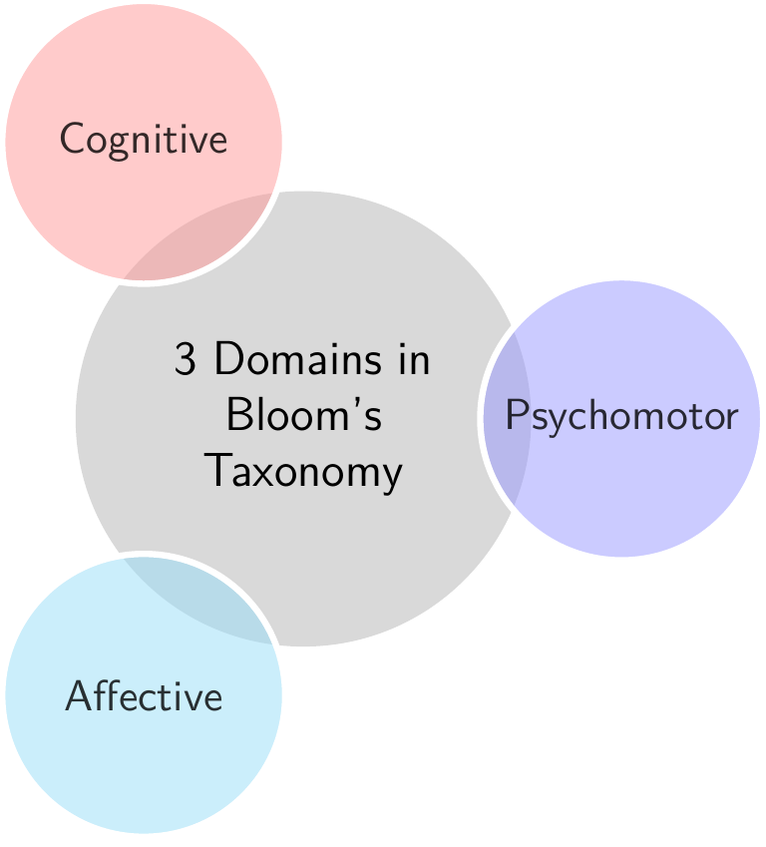

|  |  |  |  |
| --- | --- | --- | --- |
| Level | Cognitive Domain  (C) | Affective Domain  (A) | Psychomotor Domain  (P) |
| 1 | Remember (C1) | Receive (A1) | Imitate (P1) |
| 2 | Comprehend (C2) | Respond (A2) | Execute (P2) |
| 3 | Apply (C3) | Value (A3) | Perform (P3) |
| 4 | Analyze (C4) | Conceptualize Values (A4) | Adaption (P4) |
| 5 | Evaluate (C5) | Intermalize Values (A5) | Naturalize (P5) |
| 6 | Create (C6) |  |  |

**\* References: Dyjur, P. (2018). Writing Course Outcomes**